**NAME**

**COLLEGE NUMBER**

**Introduction**

**B**uiness information ysystems can be dedine as a set of untegrated set ofweb tools that consume data, anayse them and present the indights to an end user. Before proceededing here is the outline of the BI architecture:

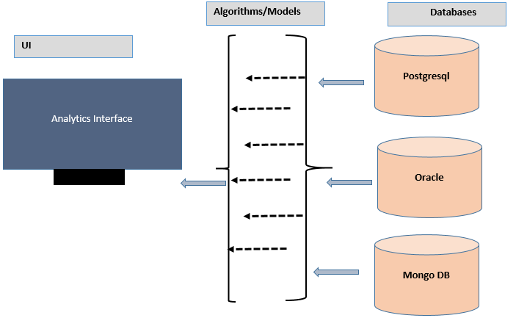

The simple illustration of the BI architecture illustrates three items:

**The user intereface:** Is the scsreen view upon which the user sees and can make reports upon which all submitted querries and reports. The unser interface is the final product upon which the user/amanegment can make descsion sbased on the vsisble analytics as we shall see in the next step.

**The Alosthms and API/Moules:** The this part of the interfacetakes the data ffrom the datastores and anad applies models, algosthms and functions uport it toporidce the required iutput. Some of the required and usual statsistical models look for, counts, means, maximum, miniumum,low, avarages ad pernectile values. Other s inlucde limits, top countowunts and latest records. Furher after analysyis, the presentaon of this data in form of graphs, charts and sctter plots.Adcvanced methods in the process of integrating with the BI also incudes predcitie analytics where cerstainstsstiatstic mdoels like LDA, QDA, KNN, Arima and Linear regression methods are applied. This is so since organisatuions would alsways want to analyse and know the future of the data they are hilding. For instance, if its sales, the departmet would like to predict whene and how they are ogoing to be seeling in the neasr future and how this maaters imn their current business procceses as ana organisation.

**Databases:**

There are two types of databases that exist:

* Structured
* Unstructured Databases

Stuctured dtabses store data in in organised rows and clomuns in what we define as tables. The items in these tables are identified by primary keys as and foreign keys. Lets llok at a sample cutormer table below:

|  |  |  |
| --- | --- | --- |
|  |  |  |
| id | name |  |
| A54649 | Jeremy lans |  |
| REF763 | Rebbeca Ohms |  |
| YYE735 | Annet kieler |  |
|  |  |  |
|  |  |  |

The structured database above shows the unique records for a customer details athat are uniquely identified by a key. On the other than, we can ahave another table for sales that show the sales detaisl for the customer above.

|  |  |  |  |  |
| --- | --- | --- | --- | --- |
| Sales id | FOR KEY | Prod_name | amount | Sale_date |
| 9655 | A54649 | Jeremy lans | 6457 | 2021-11-08 |
| 5444 | REF763 | Rebbeca Ohms | 896974 | 2021-10-12 |
| 7864 | YYE735 | Annet kieler | 745338 | 2021-09-05 |
|  |  |  |  |  |
|  |  |  |  |  |

The two tables dientfied bove are linked by thir respective primary keys, a primary key could be a foreign key in another table. This element of identsifying records across structured datavsess in the BI is eseentatila bescause it will abe crycuial in oining tables and sharing the resultant outputs on the user interface during analytics.

Unstrcutuctured databases: on the other handdo not organise data in any specific tables,clomns or